Android Car



By

Name of Students:
Saddam Hussain
Student’s Registration Number
2011-Umdb-10351
Haroon-ur-Rashid
Student’s Registration Number
2011-Umdb-10376
Junaid Ahmed Butt
Student’s Registration Number
2011-Umdb-10376

Supervisor

Engr. Zaman Fakhar
Lecturer

DEPARTMENT OF SOFTWARE ENGINEERING
FACULTY OF SCIENCES& ENGINEERING
UNIVERSITY OF AZAD JAMMU & KASHMIR
MUZAFFARABAD
Session: 2011-2015
Android Car
By
Name of Student
Saddam Hussain
Haroon-ur-Rasheed
Junaid Ahmad Butt
Student’s Registration Number
2011-Umdb-10351
2011-Umb-10376
2011-Umb-10376

Session
2011-2015
A thesis/project submitted in partial fulfillment of the requirement for the degree of
Bachelor of Software Engineering
Thesis/Project Supervisor:
Engr. Zaman Fakhar
Lecturer Department of Software Engineering

External Examiner’s Signature:

Thesis/Project Supervisor’s Signature:
DEPARTMENT SOFTWARE ENGINEERING
FACULTY OF SCIENCES & ENGINEERING
UNIVERSITY OF AZAD JAMMU & KASHMIR,
MUZAFFARABAD
ABSTRACT

Today’s RC toys are controlled by a single dedicated (and often proprietary) controller. We endeavored to develop a remote control car that would be controlled via Bluetooth wireless technology. Since Bluetooth is a standardized and relatively reliable wireless protocol, we hoped to create a car controllable by any Bluetooth device. Additionally, Bluetooth consumes low power and has a larger bandwidth than the standard 900MHz RF link which drives most toys. This added benefit allows for sending of complex information from the car to the controlling device—something unseen in consumer grade RC cars. Our computer-controlled Bluetooth car prototype showed the feasibility and practicality of Bluetooth controlled devices, while also revealing limitations in the amount of data transmission capable in commercially available Bluetooth options.

Keywords:
- Android Application
- API
- Bluetooth
- H-Bridge
- DC motor

UNdertaking

I certify that research work titled “Android car” is our own work. The work has not been presented elsewhere for assessment. Where material has been used from other sources it has been properly acknowledged/referred.

Signature of Student
Junaid Ahmed Butt
2011-Umdb-10351

Signature of Student
Saddam Hussain
2011-Umdb-10351

Signature of Student
Haroon-ur- Rasheed
2011 -Umdb-10376

Signature of Student
Junaid Ahmad Butt
2011 -Umdb-10376

Acknowledgements

Foremost, Thanks to Allah SWT, whom with His will gave us the ability and opportunity to complete this Final Year Project titled “Android Car”. Indeed we are bound to an eternal gratitude of our project supervisor Engr. Zaman Fakhar for his continuous support, guidance and excellent supervision and administration throughout the course of this project. We would also like to thank department teaching staff for their cooperation.
Besides our supervisor we would like to thank our teacher Saddam Hussain for his help, valuable suggestions, and encouragement and for being a source of inspiration to us.
Last but not the least we can’t thank our parents enough for their unconditional and unparalleled love and support during the course of our degree.

Table of Contents

Table of Contents
Undertaking 3
Acknowledgements 4
Table of Contents 5
List of figures 7
List of tables 8
Chapter 1 9
Chapter 2 13
2.1 Requirements 13
2.1.1 Android Application Requirements and Description 13
2.2 Specific Requirement 14
2.2.1 Functional Requirement 14
2.3 Software Requirement 14
2.4 Hardware requirement 14
2.5 Overall Description 15
2.5.1 Requirement Elevation 15
2.5.2 Economic Feasibility 15
2.5.3 Technical Feasibility 15
2.5.4 Legal Feasibility 16
2.5.5 Requirement Specification 16
2.6 Security 17
2.6.2 Communication’s security 17
2.6.3 Network security 17
2.6.4 Information security 17
Chapter 3 18
Chapter 4 20
4.2.2.1 Use case specification 23
Chapter 5 26
5.1 Tools & Technologies Used in Software Development 26
5.1.1 Eclipse 26
5.1.2 Android Software Development Kit and Environment 27
5.1.3 Bluestack 28
5.2 Abstract: 28
5.2.1 Coding Standards 28
5.2.2 Debugging 29
5.2.3Code walkthrough 30
5.2.3.1 Code Walkthrough Objectives: 30
5.2.3.2 Code walkthrough details 31
5.2.4Code Inspection: 32
5.2.4.1 Code Inspection Objectives: 32
5.2.4.2 Code inspection details 33
Chapter 6 35
6.2 Scope of Testing 35
6.3 Test Plan Strategy 35
6.3.1 White Box Testing 35
6.3.2 BLACK BOX TESTING 36
6.3.2.1 Unit Testing 36
6.3.2.2 Integration Testing 36
6.3.2.3 System Testing 37
6.3.2.4 Acceptance testing: 37
6.4 Requirements Verification and Validation 38
6.6 Test Environment and testing Schedule 38
6.7 Resources 39
6.7.1 System Model: 39
6.7.2 Processor: 39
6.7.3 RAM: 39
6.7.4 Hard drive: 39
6.7.5 Software Environment 39
6.8 Test Cases Implementation 40
6.8.1 White Box Testing 40
6.8.2 Black Box testing 40
6.8.2.1 Unit Testing 41
Chapter 7 46
CONCLUSIONS &RECOMMENDATIONS 49
Results 49
Abbreviations 52

List of figures

- Figure 1: Use case diagram Android BT controlled car
- Figure 2: Use case diagram of the whole system
- Figure 3: Data flow Diagram of the whole system.
- Figure 4: Architectural Diagram
- Figure 5: Android Car (user interface)
- Figure 6: Android Car (with permission required)
- Figure 7: Use Case Diagram
- Figure 8: Sequence Diagram
- Figure 9: Class Diagram
- Figure 11: Eclipse Interface showing log cat
- Figure 12: Eclipse Interface and Development Environment
- Figure 13: Android Car Home
- Figure 14: Server Window (Capturing screen)
- Figure 15: Devices and drives
- Figure 15: Connection Details
- Figure 16: Power options
- Figure 17: Design to swap activities

List of tables

- Table 5.1: System Requirements
- Table 5.2: Table 1 Code Walkthrough
- Table 5.3: Table 2 Code Walkthrough
- Table 5.4: Table 3 Code Walkthrough
- Table 5.5: Table 4 Code Walkthrough
- Table 5.6: Table 1 Code Inspection
- Table 5.7: Table 2 Code Inspection
- Table 5.7: Table 2 Code Inspection
- Table 5.8: Table 3 Code Inspection
- Table 5.8: Table 4 Code Inspection
- Table 6.1: Testing Schedule
- Table 6.2: White Box Testing
- Table 6.3: Unit Testing 1
- Table 6.4: Unit Testing 2
- Table 6.5: Unit Testing 3
- Table 6.6: Unit Testing 4
- Table 6.7: Unit Testing 5
- Table 6.8: Unit Testing 6

Chapter 1

INTRODUCTION

  - INTRODUCTION:

RF or radio frequency is an oscillation rate in a range of between 3 kHz to 300 GHz, corresponding to the frequency of the radio waves and the alternating currents carrying radio signals. RF usually refers to electrical oscillations. Electric currents which oscillate at radio frequencies have special properties that are not shared by alternating current or direct current of lower frequencies. Although radio frequency (or RF) is a rate of oscillation, the term itself is also used as a synonym for wireless radio communication.
In the last decade Smart Phones have increased exponentially in not only popularity, but also technical design. Software of the integrated systems on these handheld devices is under constant development, but is often limited by the increasing demand for compact size. Many current technologies exist that enable smart-phones to use a Bluetooth connection to control end device.
However, using an Android based smart-phone to wirelessly control the Android Car, the smart-phone must be able to wirelessly send commands for the movement and direction. These wireless capabilities require the use of some form of pre-created network.
Usually Toy Car is controlled through a remote using an RF link which is subject to attenuation, noise and has a very limited range as well.
This project features an Android Car that uses HC-06 standard which send AT command to the device and then use other protocols to make possible continuous connection. Bluetooth support high data rates which enables good quality for transmission from the Android Car to the smart-phone. Android Car can be controlled through any smart-phone wirelessly through a Bluetooth module using smart-phone.
Controlling a smart-phone by hand and finger motions alone is more intuitive than using both hands to control the smart-phone. To be able to control the car with one hand, forward key is map to move car in forward direction while reverse key is map to move in opposite direction. Turning left and rights to a car left and right keys are use.
This Android Car is capable of moving up to a distance of 200m with precise speed from the controlling smart-phone. It has rechargeable batteries which can support 1.5 hours of full operation. It is applicable for flat areas and also be applicable for like blocked tunnels, pipe lines and enemy zones which are not reachable due to high risk level, blockage or because of our physical limitations.
In the ever changing, ever progressing age that we live in today, more and more tasks back then handled by humans are now replaced with toy car. Though some may think those toy cars are slowly becoming a threat to humans especially when it comes to jobs, some toy car are designed to ease a person’s life. The toy car commonly used to defuse a bomb, enter into rubble could save a humans life which is more important compared to a mere job. Therefore, this project was chosen.
This project is just the beginning to multiple future advancement of a remote control car. This Android Car will be able to discover distant terrains be it hazardous or not.

  - Scope of application
This project is to develop a remote control car using Bluetooth communication and android devices that will enable control via Smartphone. The Android Car has a limited which is forward, backward, left and right. The speed and direction is not fixed and not potentiometer. This Android Car is high-end car which use to give precise speed and direction control. This project is developing a smart-phone by using Java programming language. To designing interfaces Bluetooth module with android phone have to take the Android Car application as a client server socket and lastly, perform system testing through the evaluation of hardware and software

  - Objectives:
There are three main objectives in pursuing the accomplishment of this project:
i. To study on smart-phone application using android: Respond to navigation commands triggered through a smart-phone using Android touchscreen smart phone in performing
ii. To control Android Car using Bluetooth communication: Maintain continuous wireless connectivity of smartphone
iii. To create a unified technical solution: To design toy car that guide user using an Android Car in indoor environment or specific location

  - Existing Application Problem:
i. Previous mobile car used Radio Frequency (RF) that had problem on transmission frequency, such as low data rate and the frequency sometimes can be shared to other frequency devices.
ii. Utilize a commercially available smart phone (for example an Android phone) to command and control the Android Car. These capabilities are applicable to multiple scenarios including military missions, police surveillance and search and rescue activities. The prototype should be developed and demonstrated using commercially available products.
iii. The range of Android Car has limits.
  - Proposed System:
The Android controlled car is a project which facilitates users to control their toy car device from a distance with optimum mobility. All that is required to have remote access to your hardware device is an android phone. The Bluetooth pass key is the only thing user must know and by entering the correct pass key user will be able to remotely access his toy car. We provide this communication between systems (Car device, Android Phone) via Bluetooth which is a very common communication medium these days.
Even at very bad weather no effect of attenuation and with a baud rate of 9600 bps this application runs like a charm and a very simple interface allows all kind of users to use it easily.
1.6 Technology to be used:

- Android Phone 4.2 or above
- Windows 10 Operating System
- ATmega1284
- Breadboard Wb -106
- L293D Motor controller
- 5V regulator
- HC-06 Bluetooth module
- 9V DC motors
- 9V Batteries
- LED lights
- Borland
- Eclipse Studio/Android Studio
- Java Platform JDK
- Android SDK
- Proton IDE
- Proteus 7.8
- Hyper Terminal
- Adobe Photoshop CS6
- Microsoft Visio 2013

Chapter 2

Requirement Analysis

This chapter focuses in detail the need for building Android Application Software. The requirement analysis section of this document focuses on some of the key needs of why there was a need to develop such an Application. Requirement analysis basically process of understanding what the need of such Software was and once it will be developed what problem it will solve.
In the Era of technology each and every person is using Mobile Phone. In current situation of Pakistan and around the world there is a threat using mobile phone for communication. People use them to take photographs, send text, update Facebook and search the web.

2.1 Requirements

2.1.1 Android Application Requirements and Description
As mentioned in the introduction of this thesis, an Android application acts as a remote control device for a Bluetooth connected car device. For this project the Android device acts as a client to the car device. The touch screen feature of the Android device is used to control the car in different direction. All the information from the phone needs to be sent to the hardware device. For the exchange of information between the Android application and hardware device, Bluetooth is used as a mediator. The functions such as enabling the Bluetooth in a device, discovering Bluetooth car, creating a connection to the hardware device and directions are all done in the user side. Figure 1 shows the whole actions performed by the Android Bluetooth control car.
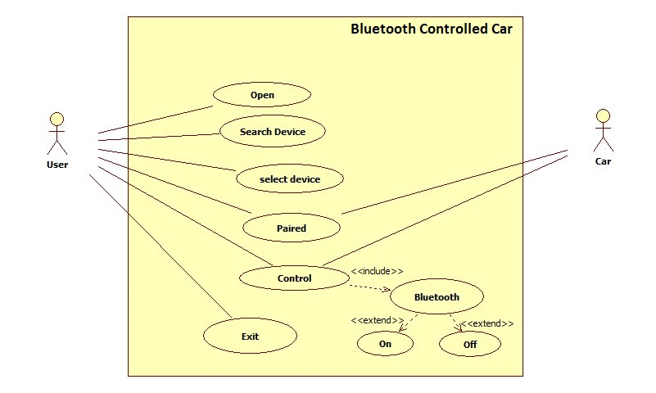
Figure 1: Use case diagram of Bluetooth Controlled Car

2.2 Specific Requirement
This section of the chapter focuses on the Functional, Hardware and Software requirements of the Android Phone Application. All core, Major and Supporting requirement will be discussed in this section.

2.2.1 Functional Requirement
Functional requirements describe what the Android Mobile Application is expected intended for remotely accessing car device. Functional requirements of the system are:
- Pairing devices (pair both hardware device and application)
- Controlling hardware device (Remotely controlling)
- Directing car (moving car in all four direction)
- Exit (shutdown Bluetooth devices)

2.3 Software Requirement

This project requires the following software.
- Android Phone 4.2 or above
- Windows 10 Operating System
- Dev
- Eclipse Studio/Android Studio
- Java Platform JDK
- Android SDK
- Proton IDE
- Proteus 7.8
- Hyper Terminal
- Adobe Photoshop CS6
- Microsoft Visio 2013

2.4 Hardware requirement
This project requires the following hardware.
- Android Phone
- Laptop
- Microcontroller ATmega1284
- PCB(Printed circuit board)
- Motor Driver L293D
- Resistor 10k
- Non polar capacitors 104pF
- Capacitors 10uF

- Crystal oscillator 4MHZ
- Voltage Regulator (L 78050v) 5V
- Diode 4007
- HC-06 Bluetooth module
- DC motors
- Heat sink
- Battery 1 Ampere
- LED lights
- Switches
- Wheels
- Flexi Glass
- Jumper wire

2.5 Overall Description

2.5.1 Requirement Elevation
After a detailed analysis we reached at the conclusion that “Android Controlled Car” will serve our needs. We decided to use XML as a front end design and java as a backend for the development of client application. On the hardware side we used assembly language in embedded C burned in Microcontroller.

2.5.2 Economic Feasibility
Eclipse Studio , Blue stack , Android SDK, JDK, Protius 708, Proton IDE, HyperTerminal are all available on the internet for free and are also open source which can be downloaded easily from the internet. So, the development of software is almost free, but Hardware is not available for free so it makes some cost.

2.5.3 Technical Feasibility
Project is technically feasible because of the following reasons.
Java is the one of the most widely used programming language and so many software are built using java. So, it is somewhat a universal language for all platforms. We choose java for the development of Android application because there is lot of help and solutions for the problem which are encountered during the application development. Whereas C language is also one of the most widely used language and lot of work has been done in C language so that we use C language in developing hardware which makes easy to encountered problems during hardware development.

2.5.4 Legal Feasibility
The system is based on both hardware and software that does not concern to any organization that is the reason our system is legally feasible.

2.5.5 Requirement Specification
In this project Android application is use by the user to control toy car. Application contains the user interface of the application. Most of the time during the use of application the user interacts with the Android application part than the hardware. All the works such as pairing to the toy car, sending data to the toy car, controlling toy car wirelessly over Bluetooth are done by the user application. Figure 3 shows the flow chart of the Android BT controlled car.
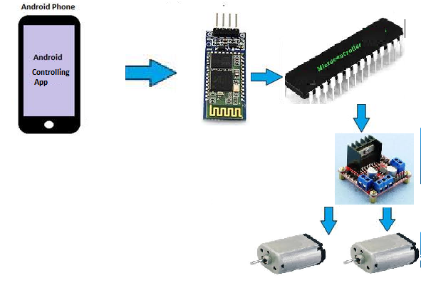
Figure 3 Data flow Diagram of the Android BT controlled car.
Figure 3 shows the steps that take place during the use of the application to control toy car. When the application is started the availability of Bluetooth is checked. Before using this application, it should be kept in mind that both Android application and hardware system should have Bluetooth connection. If available the application prompts to scan the Bluetooth device which we write the name of Bluetooth in the text box in application. If not already connected, the application provides a dialog box giving a message of socket error and also if toy car is not connected Bluetooth blinks, when it connected its light become stable. The toy car must already be active when the application sends the request for connection.
It should be noted that for making pair with toy car application will require pin key for more secure connection, after accepting valid pin key toy car will be able to build a connection with application. User can now able to control car and moves it in all four direction. The user can now simply end the connection by closing the application or switch off the toy car device. It should be noted that the connection will be built only if the toy car is connected to same network.

Limitations:
At this point this application has a few limitations like:
- The devices will be connected only if they are on the same network.
- The range to which the user can access the toy car device is about 10-15m (<15).
- Bluetooth is a good communication system but not effective while working in a longer range.
- The rechargeable battery can give power up to one hour.
- Car cannot be move effectively in rough surface.

2.6 Security
Security is classified into different layers depending on the type of content intended to be secured.
2.6.1 Personal security
The use of pass key makes the communication safe and secure between user and device.

2.6.2 Communication’s security
The use of AT protocol ensures the communication is done without loss and even at low battery power.

2.6.3 Network security
The use of serial communication, sockets and ports makes the communication secure.

2.6.4 Information security
The information exchange during the connection is safe and loss less.

Chapter 3
Android Based toy car

This Chapter is mainly focused on the planning to establish a contextual basis for this thesis as a whole. This chapter starts off with brief introduction of Android BT controlled car and describes the design phase of application.
The objective of this project is to develop a remote control car using Bluetooth communication and android devices that will enable control via Smartphone. The Android Car has a limited which is forward, backward, left and right.

3.1 A need for Android controlled car:
In the last decade Smart Phones have increased exponentially in not only popularity, but also technical design. Software of the integrated systems on these handheld devices is under constant development, but is often limited by the increasing demand for compact size. Many current technologies exist that enable smart-phones to use a Bluetooth connection to control end device.
However, using an Android based smart-phone to wirelessly control the Android Car, the smart-phone must be able to wirelessly send commands for the movement and direction. These wireless capabilities require the use of some form of pre-created network.
Usually Toy Car is controlled through a remote using an RF link which is subject to attenuation, noise and has a very limited range as well.
This project features an Android Car that uses HC-06 standard which send AT command to the device and then use other protocols to make possible continuous connection. Bluetooth support high data rates which enables good quality for transmission from the Android Car to the smart-phone. Android Car can be controlled through any smart-phone wirelessly through a Bluetooth module using smart-phone.
Controlling a smart-phone by hand and finger motions alone is more intuitive than using both hands to control the smart-phone. To be able to control the car with one hand, forward key is map to move car in forward direction while reverse key is map to move in opposite direction. Turning left and rights to a car left and right keys are use.
This Android Car is capable of moving up to a distance of 15m with precise speed from the controlling smart-phone. It has rechargeable batteries which can support 1.5 hours of full operation. It is applicable for flat areas and also be applicable for like blocked tunnels, pipe lines and enemy zones which are not reachable due to high risk level, blockage or because of our physical limitations.
In the ever changing, ever progressing age that we live in today, more and more tasks back then handled by humans are now replaced with toy car. Though some may think those toy cars are slowly becoming a threat to humans especially when it comes to jobs, some toy car are designed to ease a person’s life. The toy car commonly used to defuse a bomb, enter into rubble could save a humans life which is more important compared to a mere job. Therefore, this project was chosen.
This project is just the beginning to multiple future advancement of a remote control car. This Android Car will be able to discover distant terrains be it hazardous or not.
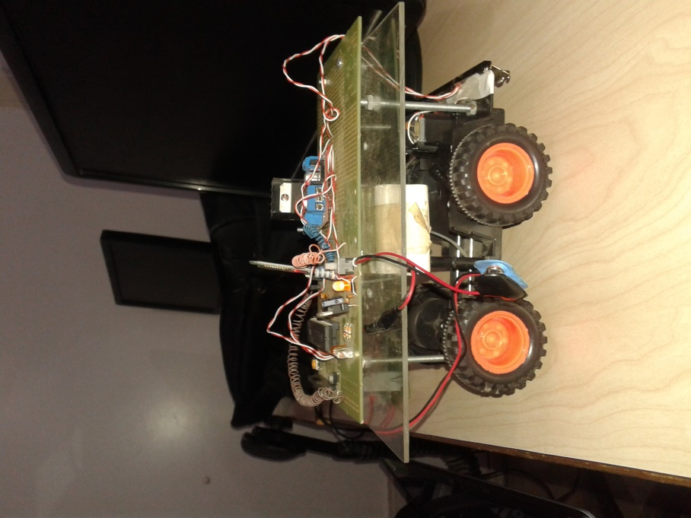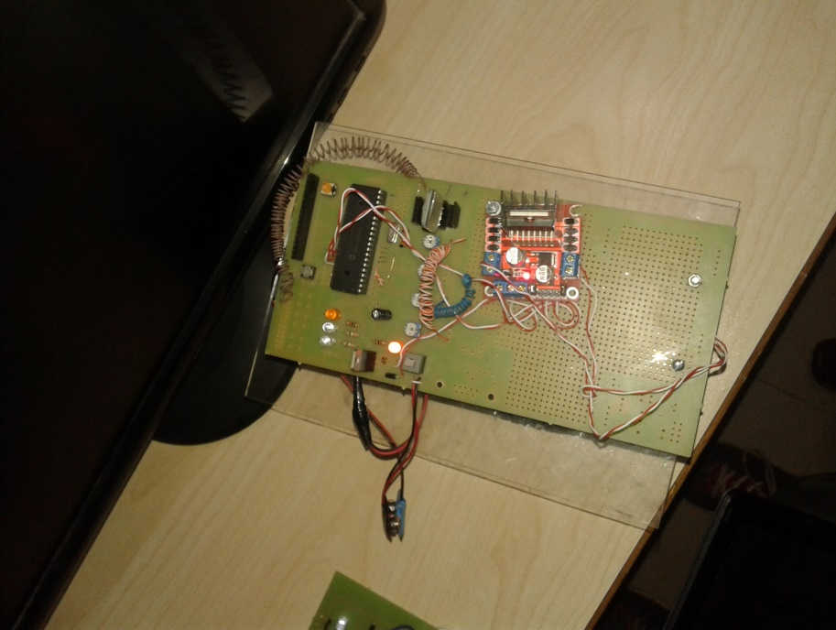

3.2 Key features of the proposed system
The key features of the proposed system are as follows:
1. The application is developed Android architecture considering its compatibility over different Android phone devices.
2. The application is very carefully developed considering the limited available memory and power (battery life) in mobile and hardware device.
3. The application has very simple design due to which it can be used by all kinds of users.
4. The application gives user the facility to control toy car over Bluetooth through his smart phone.
5. Even at low communication speed the application runs smoothly without much delay and interruptions.

3.3 Android controlled car:
The application works as mentioned in the following manner:
- Firstly the user should open the application on his mobile.
- Then built your HC-06 Bluetooth module pair with your mobile.
- Password for pairing is “1234” or “0000”.
- Write name of the slave Bluetooth name in the text box and then tap connect button to pair Bluetooth module.
- When press “up arrow” it sends the data “A” to Bluetooth module connected with the circuit. When microcontroller detects “A” the toy car moves FORWORD.
- When press “DOWN ARROW” it sends the data “B” to Bluetooth module connected with the circuit. When microcontroller detects “B” the toy car moves REVERSE.
- When press “LEFT ARROW” it sends the data “C” to Bluetooth module connected with the circuit. When microcontroller defects “C” the toy car turns LEFT.
- When press “RIGHT ARROW” it sends the data “D” to Bluetooth module connected with the circuit. When microcontroller defects “D” the toy car turns RIGHT.
- The user can exit his application or he can switch off toy car circuit.

Chapter 4

Architecture and Design

This chapter includes detailed information of the work during the design phase of the system which includes the design and architecture in detail. Best practice for designing for project is discussed in detail.

4.1 Architecture:
4.1.1 Client Application Architecture
The Android application for this project acts as the client and car hardware is acts as a server. The client application contains the user interface of the application. Most of the time during the use of application the user interacts with the client part than the server. All the works such as connection to the hardware, sending data to the hardware device, controlling the toy car wirelessly via Bluetooth are done by the client application. Figure 4 shows the architectural diagram of android controlled car application.
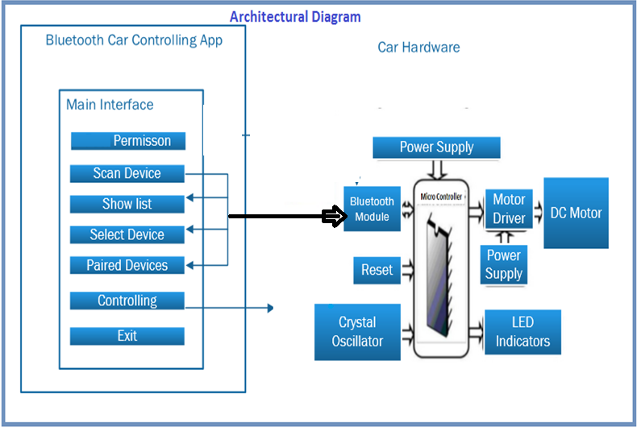

Figure 4.Architectural diagram of Android controlled car application.

Figure 4 shows the steps that take place during the use of the application. When the application is started the availability of Bluetooth is checked. Before using this application, it should be kept in mind that both Android application and hardware system should have Bluetooth connection. If available the application prompts to scan the Bluetooth device which we write the name of Bluetooth in the text box in application. If not already connected, the application provides a dialog box giving a message of socket error and also if toy car is not connected Bluetooth blinks, when it connected its light become stable. The toy car must already be active when the application sends the request for connection.
It should be noted that for making pair with toy car application will require pass key for more secure connection, after accepting valid pass key toy car will be able to build a connection with application. User can now able to control car and moves it in all four direction. The user can now simply end the connection by closing the application or switch off the toy car device. It should be noted that the connection will be built only if the toy car is connected to same network.
The user interface in an Android application can be designed by coding in an xml file. Different types of layouts, buttons, colors and other user interface elements can be added to the xml file. Different other elements such as dialog boxes, text box, widgets, and images can also be added to the views. The xml provides the views that appear to a user. Figure 5 shows the user interface of the android application.

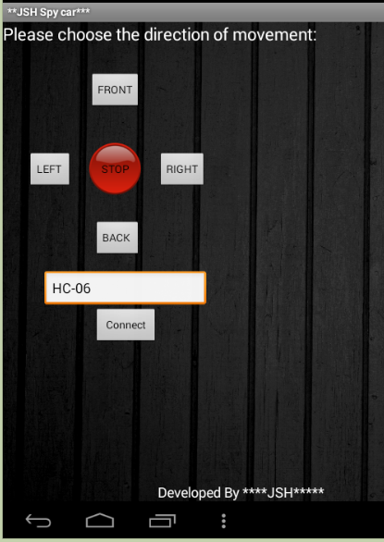

Figure 5: Android BT controlled car App (user interface)

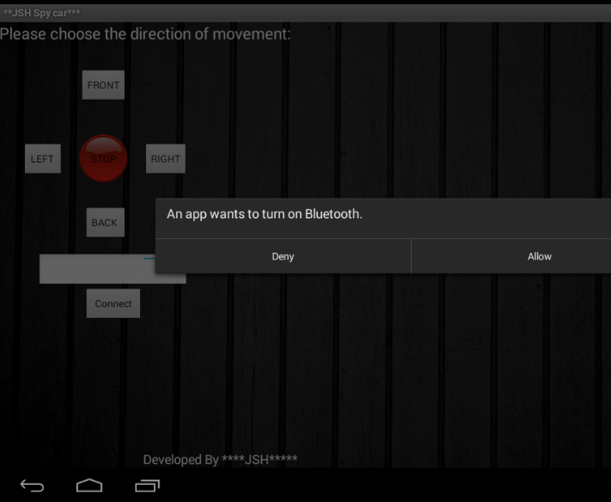

Figure 6: Android BT controlled car app

4.2 Design Phase:

4.2.1 Use Case Diagram

Figure 7: Use Case Diagram

4.2.2.1 Use case specification

- Primary actor:
User using the Android BT application is the primary actor of this use case.

- Pre-condition:
The user should connect the Android application to the hardware with which the toy car is connected.

- Main scenarios:
There are number of main scenarios in our application.
- Firstly the user should open the application on his mobile.
- Then built your HC-06 Bluetooth module pair with your mobile.
- Password for pairing is “1234” or “0000”.
- Write name of the slave Bluetooth name in the text box and then tap connect button to pair Bluetooth module.
- After connection built user will be able to control and give direction to the toy car.
- The user can exit his application or he can switch off toy car circuit.

4.2.2 Sequence Diagram

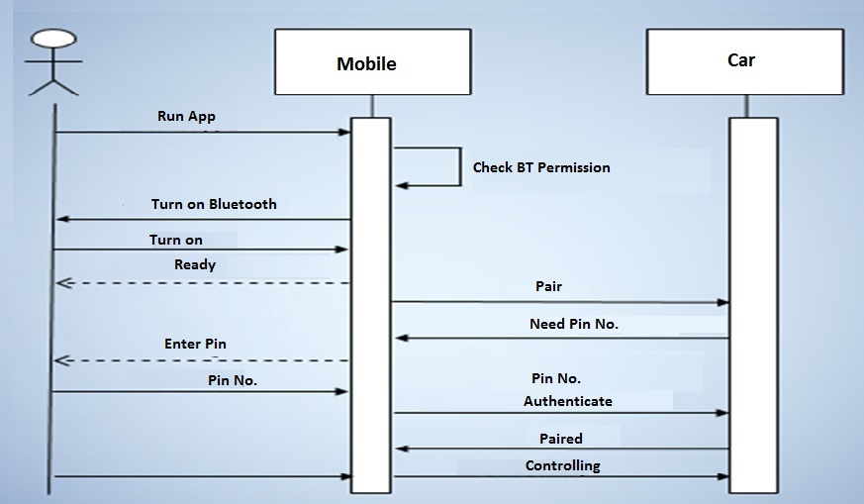
Figure 8: Sequence Diagram
Figure 6 illustrates When the application is started the availability of Bluetooth is checked. Before using this application, it should be kept in mind that both Android application and hardware system should have Bluetooth connection. If available the application prompts to scan the Bluetooth device which we write the name of Bluetooth in the text box in application. If not already connected, the application provides a dialog box giving a message of socket error and also if toy car is not connected Bluetooth blinks, when it connected its light become stable. The toy car must already be active when the application sends the request for connection.
It should be noted that for making pair with toy car application will require pass key for more secure connection, after accepting valid pass key toy car will be able to build a connection with application. User can now able to control car and moves it in all four direction. The user can now simply end the connection by closing the application or switch off the toy car device.

4.2.3 Class Diagram:

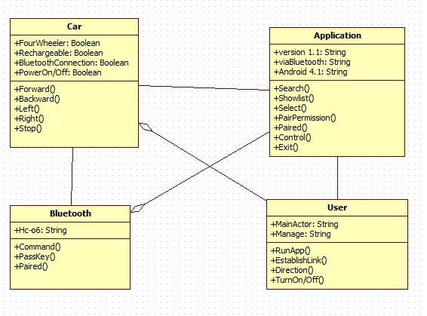
Figure 9: Class Diagram

Chapter 5

Implementation and technology

This chapter includes detailed information of the work during the implementation phase of the system which includes the design tools and technologies in detail. Best practice for coding for project is discussed in detail.

5.1 Tools & Technologies Used in Software Development
Tools used for development of our software are Eclipse, Android SDK, Proteus 7.8, Proton IDE and Blue stack as Emulator.

5.1.1 Eclipse
Eclipse is an open-source IDE donated to the community by International Business Machine (IBM). Java and the Android programs are written using Eclipse. Eclipse can also be used to program in other programming languages by means of external plugins. Also the plug-ins can extend the usability of Eclipse. Eclipse is developed by an open source community which has about 2000 open source projects related to different aspects of software development. Syntax-highlighting editor, incremental code compilation, a thread-aware source-level debugger, a class navigator, a file/project manager, and interfaces to standard source control systems are the features provided by Eclipse, once combined with JDT.
Eclipse was started as project for IBM which later in 2001 was released as an open source project. An association was then formed for further development of Eclipse as open source, and the original board members were Borland, IBM, Merant, QNX Software Systems, Rational Software, Red Hat, SusE, TogetherSoft and WebGain. Later in 2004 the Eclipse foundation was formed. It is a nonprofit organization responsible for governing the Eclipse projects. Figure 8 shows the basic window of the Eclipse.
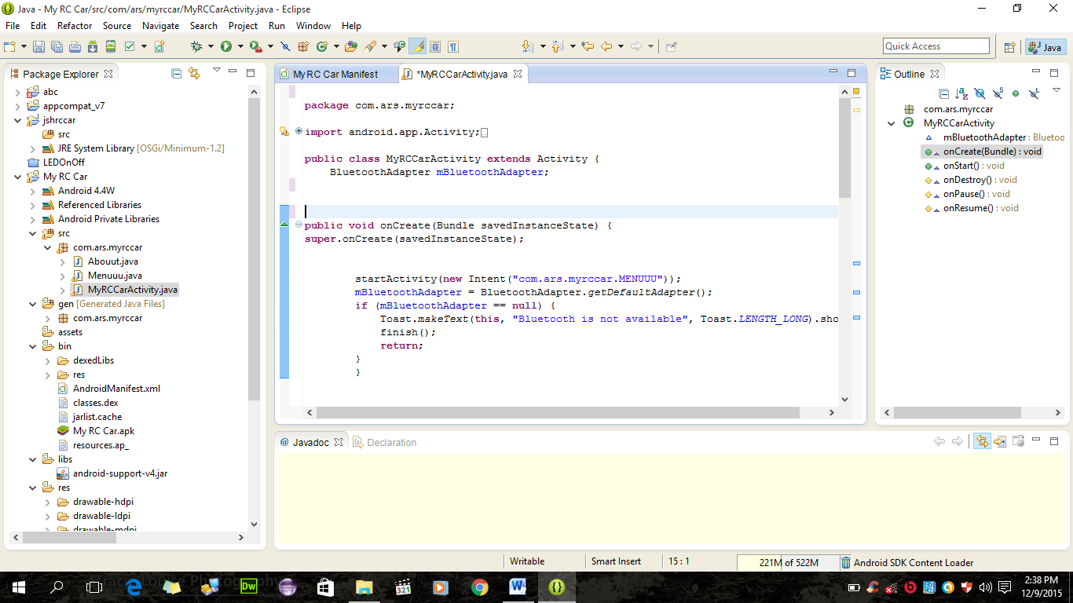
Figure 10 Eclipse user interface.
Above screenshot shows a simple user interface of Eclipse IDE. The whole figure is known as the work bench window. The window consists of a package explorer view, a type hierarchy view, a Java outline view, wizards for creating the Java elements, a Java editor, a short cut bar, a menu bar and a tool bar, as shown in figure 6. The Package explorer shows the entire project that is currently in the workspace and the project highlighted in the package explorer is the project that is currently in use. The Type hierarchy view shows the sub and super hierarchies whereas the Java outline view shows the classes and the Java units. Wizards for creating the Java elements consist of the Java classes, packages and interfaces. The Java editor is where all the codes for application development are written. The codes can be highlighted, edited or fixed in this area. All the commands such as edit, run, build and others are included in the shortcut bar, menu bar and tool bar. To develop the client-side application of the project in the Android platform using the Java programming language, Eclipse was used.

5.1.2 Android Software Development Kit and Environment
The Android SDK is a collection of software development kits used to develop applications in the Android platform. The Android SDK is available for free to download and use from the official Android developers’ website. The SDK is available for all operating systems. It can be used alone to develop an application with a command prompt or can be used with IDEs such as Eclipse and NetBeans. The IDE provides a graphical interface for easier and faster development of an application. The Android SDK consists of the following features:
- Required libraries
- Debugger
- An emulator
- Documentation for the Android application program interfaces (APIs)
- Sample source code
- Tutorials for the Android operating System.
For each release of a new version of Android, a corresponding SDK is released. A separate SDK is available for a separate version of Android. In order to use the latest feature in Android, developers need to install the latest SDK depending on the phone’s Android version. To develop an application Android provides a custom plug-in for Eclipse called ADT. ADT provides an integrated environment for development of an application by extending the abilities of Eclipse. This helps developers to create an Android project, design an application user interface, debug an application and export and import an application package. The native language used for the Android application development is Java for which Java Development Kit (JDK) is needed. JDK can be downloaded for free from official Sun Microsystems website. All the above mentioned plug-ins and IDEs are available for free downloads, and complete sets of instructions on installation are available on the Android official website.

5.1.3 Bluestack
The BlueStacks App Player is designed to enable Android applications to run on Windows PCs and Macintosh computers. Bluestack Emulator is a desktop application that emulates an Android Phone. It provides a virtualized environment in which we can test. It also provides an isolated environment for application prototypes.
Bluestack Emulator is designed to provide comparable performance to an actual device.
Table 5.1: System Requirements
System Requirements
Processor | 64 bit System: 2.13 GH or faster.  Recommended 2GH
RAM | 64 bit System: 4 GB or higher.  Recommended 4GB
Hard Disk | Minimum 4GB or higher  Recommended 4GB
Size | 262 MB
Operating System | Windows 10

Explanation about protius 7.8 and proton IDE

5.2 Abstract:
This document consists of coding standards that are used while designing the software. Moreover, it contains a brief report of coding walkthrough and coding inspection. Coding walkthrough has been done by the people from outside of group member. However, coding inspection is been done by team members.

5.2.1 Coding Standards
5.2.1.1 Coding standards used in development:
The following rules have been followed during the development phase of our project:
- Coding has been done as simple and readable as possible. Coding is done in a way that it is readable and understandable to any person who knows a little programming.
- No GOTO statement has been used to avoid complexity.
- Comments have been used for better understanding of the code. Where ever new functions and methods are coded their small description is mentioned.
- Meaningful comments have been used before classes and piece of code for documenting the code properly.
- Incomplete codes have been removed and the codes that are to be used in future are comment properly.
- Constants are not hard coded. They have been put in meaningful named variables.
- The indentation and Braces in the coding are symmetric and consistent.
- The variable names are according to their purpose.
- Empty white spaces have been used to enhance readability and are extremely helpful in testability and maintainability.
- Code file is well commented, it is very easy to understand.
- Code lines are not long to avoid difficulty to understand.

5.2.2 Debugging
Debugging is the process of finding and locating errors. Different techniques are used for debugging during the development of the project which are discussed below:
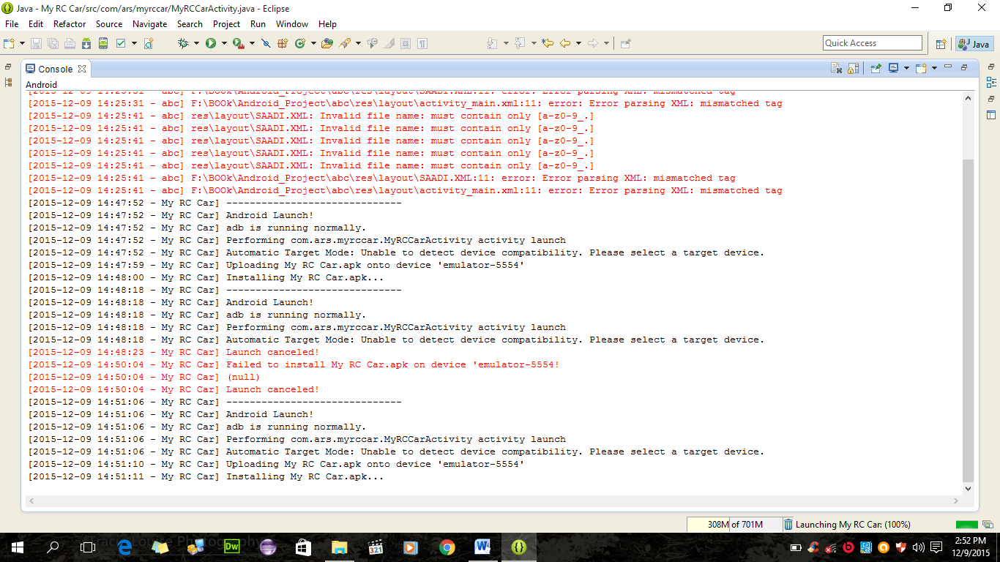
Figure 11: Eclipse Interface shows debugging

In this software application, debugging has been done by putting break points in the code. Android emulator and Eclipse provides the tools to debug which has been widely used for the debugging of the application. Android application development also provides different other tools to debug. We have used eclipse debugging environment to debug our application.
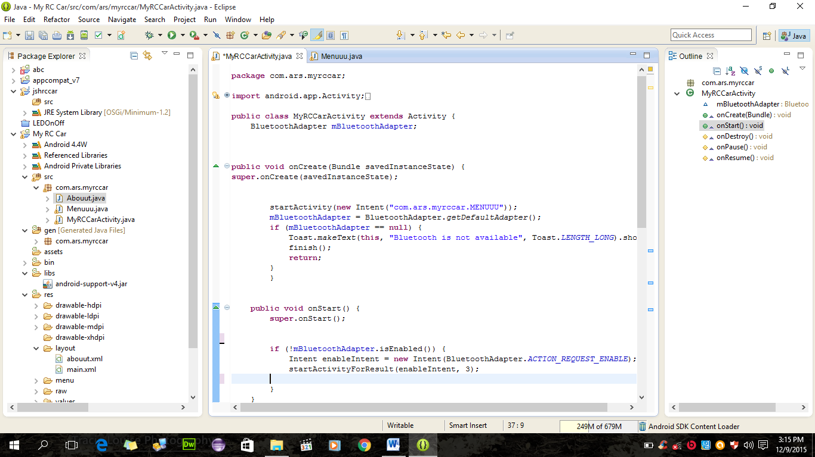
Figure 12: Eclipse Interface and Development Environment
Moreover the code has been reviewed by group members and the supervisor to avoid errors and misbehavior of the application.

5.2.3Code walkthrough
A source code walkthrough often is called a technical code walkthrough or a peer code review. This is also known as dry run test. A typical walkthrough scenario can be of a developer inviting his technical lead to review prior to implementation. Often the modified code is represented by the comments in the code.

5.2.3.1 Code Walkthrough Objectives:
The objectives of code walkthrough are given below
Objective - Check the code for:
- Standards coding violations
- Lack of clarity in coding
- Variable related to their mean
- Algorithmic and logical Errors
- Inconsistency
Resources - code walkthrough requires:
- Author
- Developer
- Designer
- External programmers
- Objects
- Code listing
- compiler listings
- Technical documentation

5.2.3.2 Code walkthrough details

Table 5.2: Table 1 Code Walkthrough
Source file names | AndroidManifest.xml  Main.xml  hardmenu.xml  About.xml  String.xml
Name of reviewer | Engr. Saleem Ahmad
Reviewer Position | Senior Programmer
Feedback | Approved
Dated | 18-Oct-2015

Table 5.3: Table 2 Code Walkthrough
Source file names | We will right hardware code
Name of reviewer | Junaid Ahmad Butt
Reviewer Position | Student
Feedback | Approved
Dated | 20-Oct-2015

Table 5.4: Table 3 Code Walkthrough
Source file names | mycarActivity.java  Menuuu.java
Name of reviewer | Haroon-ur-Rashid
Reviewer Position | Student
Feedback | Approved
Dated | 22-Oct-2015

Table 5.5: Table 4 Code Walkthrough
Source file names | BuildConfig.java  R.java
Name of reviewer | Saddam Hussain
Reviewer Position | Student
Feedback | Approved
Dated | 25-Oct-2015

5.2.4Code Inspection:
In code inspection code is viewed dynamically for errors. It is done after code is compiled. It requires an experienced staff that should be able to do it in systematic manner.

5.2.4.1 Code Inspection Objectives:
Objective - Check the code for:
- Jumps into loops
- Nonterminating statements
- Use of uninitialized variables
- Incompatible assignments
- Array indices out of bounds
- Improper storage allocation and de-allocation
- Mismatches between actual and formal parameter in procedure calls
- Improper modification of loop variables
Resources - code inspection requires:
- Author of code
- Fellow Programmers
- Experienced leader
- Compiler
- Major Code inspection implementation
All code files have been reviewed dynamically. Each file has been shortly checked for the objectives checklist of code inspection. The code inspection was done by every team member.

5.2.4.2 Code inspection details
Code inspection has been done by the team member. Each member inspects the other member’s code files. The files has been exchanged among member and inspected.

Table 5.6: Table 1 Code Inspection
Source file names | BuildConfig.java  R.java
Name of Inspector | Haroon-ur-Rashid
Position of Inspector | Student
Feedback | Approved
Dated | 28-Oct-2015

Table 5.7: Table 2 Code Inspection
Source file names | AndroidManifest.xml  Main.xml  hardmenu.xml  About.xml  String.xml
Name of Inspector | Junaid Ahmad Butt
Position of Inspector | Student
Feedback | Approved
Dated | 29-Oct-2015

Table 5.8: Table 3 Code Inspection
Source file names | mycarActivity.java  Menuuu.java
Name of Inspector | Saddam Hussain
Inspector Position | Student
Feedback | Approved
Dated | 29-Oct-2015

Table 5.8: Table 4 Code Inspection
Source file names | Main.xml  hardmenu.xml  About.xml
Name of Inspector | Engr. Saleem Ahmad
Inspector Position | Supervisor
Feedback | Approved
Dated | 29-Oct-2015

Chapter 6

Implementation and technology

This chapter uncovers the different aspects of tests that are done on the software. Each and every test that has been documented has been explicitly categorized. Test cases for which test has been performed are explained in detail in appendix of document.

6.1 Introduction:
The product specified in this SRS is Android phone Application. This is an application which allows the user to use his application to remotely control toy car via Bluetooth and moves device in all four direction.

Scope of Testing
The Scope of testing this application was to test whether the user can control his car device via Bluetooth without interruptions and data loss. The application is also been tested whether one or more user can control car device or not at a same time. The application is also tested for the range from which the car device can be accessed remotely.
On the Hardware side the whole circuit is tested whether it works fine, everything in the circuit is operating well and does not affect the performance of the hardware. The server is also tested for the range to which it can perform it works.

Test Plan Strategy
The primary objective of the testing was to check the efficiency and effectiveness of the application and to check the range to which the transmission between hardware and user application is smooth and uninterrupted.

To test the application following techniques has been used:

White Box Testing
In white box testing the internal structure of the system is considered.
There are 3 types of white box testing
- Statement Coverage: Every statement in project program is executed at least once.
- Branch Coverage: For branch coverage all the branches in our project code is tested thoroughly.
- Path Coverage: For path coverage all linear independent paths are executed and tested.
Methodology:
- White box testing was performed by all participants.
- Statement Coverage testing was performed.
Participants:
- Haroon-ur Rashid
- Saddam Hussain
- Junaid Ahmad Butt

BLACK BOX TESTING
Black box testing for this project is done and all the functionalities which were explained in the SRS are been tested and all the tests are successful. The project is fully working and it is performing all the required functionalities.

Unit Testing
Individual tests for the every module have been under taken. The modules that were tested are:
- Transmission
- Connectivity
- Device
- Range

Participants:
- Junaid Ahmad Butt
- Saddam Hussain
- Haroon-ur-Rashid

Methodology:
- All project participants have performed testing on each module of the software.
- The transmission code has been tested by an external supervisor and he didn’t write the code for transmission between the car device and the user application.

Integration Testing
The Whole System has been tested after the integration of modules by using the following approaches and techniques:

Big Bang Approach: The entire software and hardware package has been tested as a whole.

Incremental construction strategy:
- During the development of the software small tests have been performed while incrementing the functionalities and modules.
- By using the incremental strategy the errors were comparatively easy to find and were fixed.

Participants:
- Saddam Hussain
- Haroon –ur-Rashid
- Junaid Ahmad Butt

Methodology:
- Different units or parts were united in the main program.
- Also different parts of hardware were united.
- Incremental Construction strategy was used.
- All members of group did this job.
- The interface and hardware components were tested to find the errors.
- Each error was handled accordingly.

System Testing
Software was validated by combining different elements of system to check whether they give the desired output or not. Both hardware and user applications were tested at the same time and the connection and transmission between the hardware and user application was successful and reliable.

Participants:
- Engr. Zaman Fakhar
- Haroon-ur-Rashid
- Junaid Ahmad Butt
- Saddam Hussain

Methodology:
System testing was performed by all participants.

Acceptance testing:
The requirements mentioned in the SRS were checked by the testing the software and the software are meeting all the requirements.
Internal Acceptance Testing (Also known as Alpha Testing) was done by the project supervisor and it was concluded that the software meets all the desired requirements.

Participants:
Engineer Zaman Fakhar

Requirements Verification and Validation
The Purpose of Requirements Verification and validation was to check the software system that it meets its requirements specification and fulfills its intended purpose.
Requirements Verification:
The whole System is entirely tested and verified by imposing different conditions on different phases of the development.
Requirements Validation: The Entire system has been developed, tested thoroughly and validated. It performs all the required functionalities as described in the software requirement specification document.
6.5 Solution validation and Analysis of data
Solution Validation:
We worked on establishing wireless serial communication with a four wheeler car using any Bluetooth device. We worked with both computer and mobile Bluetooth and we become successful after lots of trial and error. Its operation is very safe and there is almost no risk in handling this process. The total cost is also much economic. It can be used in various sectors in our daily life easily by adding extensions.
Analysis of the Data:
Our model car is tested by us many times. We have found a very positive output from it. Thought at first we are facing problem setting the baud rate for microcontroller. But now both the mechanical and electrical parts are working well with each other. The range of controlling the car from any smartphone is less than 100 meter but it is quite satisfactory. The operating application which was made by us is very simple to use so everyone is controlling the car by it. Both the button control and accelerometer function of the android application works perfectly while controlling the car.

Test Environment and testing Schedule
The Android phone application has been tested in Eclipse and Blue Stack emulator.

Table 6.1: Testing Schedule
Testing Activities | Start | End | Person Responsible
Designing Test Cases | 08th October 2015 | 12th October 2015 | Saddam Hussain
Categorize Test Cases | 15th October 2015 | 20th October 2015 | Haroon-ur- Rashid
White Box Testing | 22th October 2015 | 23th October 2015 | Junaid Ahmed Butt
Unit Testing | 24th October 2015 | 25th October 2015 | Haroon Rashid
Integration Testing | 25th October 2015 | 27th October 2015 | Junaid Ahmed Butt  Sadddam Hussain
System Testing | 27th October 2015 | 28th October 2015 | Haroon Rashid,  Junaid Ahmed Butt  &  Sadddam Hussain
Acceptance Testing | 05th November 2015 | 11th November 2015 | Engr. Zaman Fakhar

Resources

System Model:
It is the motherboard developed by Intel Cooperation in June 2011. Its properties are shown below:
- System Model: Hp Probook 4540s
- Max Memory Size: 8 GB
- Memory Types: DDR2

Processor:
- Model: Intel Core i5 n Series
- Number of Cores: 4
- Number of Threads: 4
- Clock Speed: 2 GHz
- L2 Cache: 4 MB

RAM:
Kingston DDR2 800 MHz 4GB x1

Hard drive:
- Size: 720 GB
- Cache: 4 MB
- Interface: SATA 6 Gb/s
- Spin Speed: 5600 rpm
- Average Latency: 4.16ms
- Annual Failure Rate: 0.34%

Software Environment
- Eclipse Juno
- Android SDK
- Java Development Kit

Test Cases Implementation
Designed Test cases are in appendix with full description

White Box Testing

Table 6.2: White Box Testing
Test Engineer:  Junaid Ahmed Butt | Reviewed: Haroon Rashid  &  Saddam Hussain | TestDate:09-10  November 2015
WHITE BOX TEST RESULT
Files for which branch coverage test was not performed do not contain branches
Code File Name | Statement Coverage Test | Branch Coverage
mycarActivity.java | Successful | Successful
Menuuu.java | Successful | Successful
BuildConfig.java | Successful | Successful
R.java | Successful | Successful

Black Box testing
Table 6.3: Black Box Testing

TestCase Reference ID: |  | TC-02 |  | QA Test Engineer |  | Haroon-ur-Rashid
Test case Version: |  | 1.0 |  | Reviewed By |  | Junaid Ahmed Butt  &  Saddam Hussain
Test Date: |  | 25th November 2015
Revision History |  | None
Objective |  | Controlling device
Pre-Condition |  | Devices connected, access allowed.
Environment: |  | Windows 10 an android phone 4.2
Step No. | Execution description |  |  |  | Procedure result
1 | Controlling device |  |  |  | Device control
Comments
The test was successful.
 |  |  | Passed Failed Not Executed

Unit Testing
Table 6.3: Unit Testing 1
Test Case Reference ID: |  | TC-03 |  | QA Test Engineer |  | Haroon-ur- Rashid
Test case Version: |  | 1.0 |  | Reviewed By |  | Junaid Ahmed Butt  &  Saddam Hussain
Test Date: |  | 17th November 2015
Revision History |  | None
Objective |  | Start application
Pre-Condition |  | JDK not Installed
Environment: |  | Windows 8.1
Step No. | Execution description |  |  |  | Procedure result
1  2 | Install JDK 1.7 or above  Start application |  |  |  | Installed  Application Running
Comments
The test was successful.
 |  |  | Passed Failed Not Executed

Table 6.4: Unit Testing 2
Test Case Reference ID: |  |  |  | TC-04 | QA Test Engineer |  | Haroon-ur- Rashid
Test case Version: |  |  |  | 1.0 | Reviewed By |  | Junaid Ahmed Butt  &  Saddam Hussain
Test Date: |  |  |  | 21thNovember 2015
Revision History |  | None
Objective |  | Power on/ Start Hardware device
Pre-Condition |  | Battery not connected
Step No. | Execution description |  |  |  |  | Procedure result
1  2 | Check Hardware circuit  Start Device |  |  |  |  | Circuit is working  Device running
Comments
The test was successful.
 |  |  | Passed Failed Not Executed
Table 6.5: Unit Testing 3
Test Case Reference ID: |  | TC-05 |  | QA Test Engineer |  | Haroon-ur- Rashid
Test case Version: |  | 1.0 |  | Reviewed By |  | Junaid Ahmed Butt  &  Saddam Hussain
Test Date: |  | 17th November 2015
Revision History |  | None
Objective |  | Start application
Pre-Condition |  | JDK not Installed
Environment: |  | Windows 8.1
Step No. | Execution description |  |  |  | Procedure result
1  2 | Install JDK 1.7 or above  Start application |  |  |  | Installed  Application Running
Comments
The test was successful.
 |  |  | Passed Failed Not Executed

Table 6.6: Unit Testing 4
Test Case Reference ID: |  | TC-06 |  | QA Test Engineer |  | Saddam Hussain
Test case Version: |  | 1.0 |  | Reviewed By |  | Junaid Ahmed Butt  &  Haroon-ur-Rashid
Test Date: |  | 22th November 2015
Revision History |  | None
Objective |  | Connect to Hardware device
Pre-Condition |  | Both Hardware and Application connected to same network
Environment: |  | Windows 10 and Android Phone 4.2
Step No. | Execution description |  |  |  | Procedure result
1  2  3 | Power on Hardware  Start Android Application  Enter Pass Key and start controlling |  |  |  | Hardware Running  Application running  Passkey matched, Devices Connected.
Comments
The test was successful.
 |  |  | Passed Failed Not Executed

Table 6.7: Unit Testing 5
Test Case Reference ID: |  | TC-07 |  | QA Test Engineer |  | Saddam Hussain
Test case Version: |  | 1.0 |  | Reviewed By |  | Junaid Ahmed Butt  &  Haroon-ur- Rashid
Test Date: |  | 25th November 2015
Revision History |  | None
Objective |  | Directing Car
Pre-Condition |  | Devices connected
Environment: |  | Windows 10 and Android Phone 4.2
Step No. | Execution description |  |  |  | Procedure result
1  2 | Enter Passkey  Controlling car |  |  |  | Passkey matched  Access allowed to control
Comments
The test was successful.
 |  |  | Passed Failed Not Executed

Chapter 7

Interface Design

This is first screen of our project shows the edit box for entering the IP address and start button to start transmission.
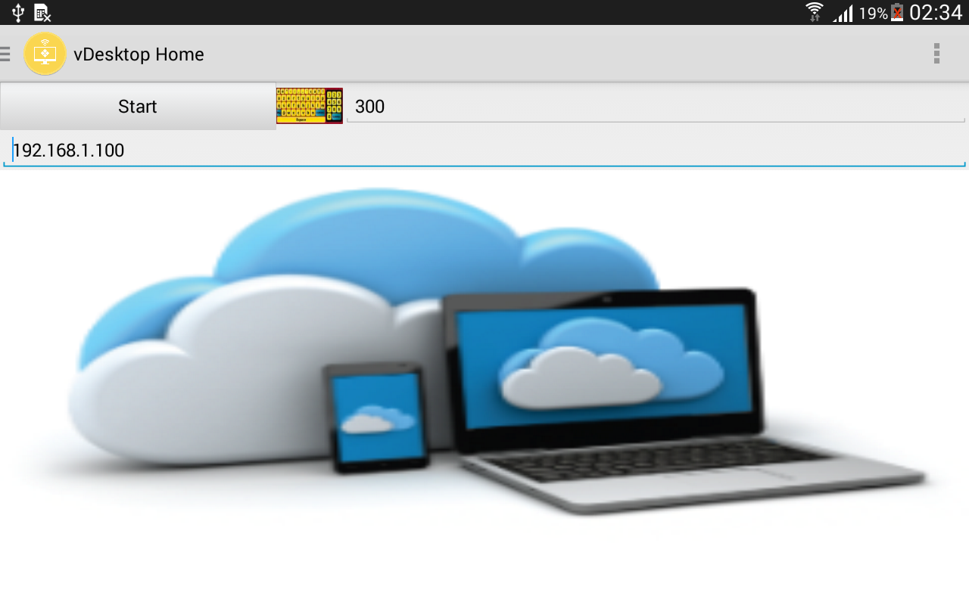
Figure 13: vDesktop Home
After you enter the correct IP address with which your server computer is connected the server window is shown which can be minimized, maximized and resized according to the will. Server Window can be minimized or maximized through the client application.
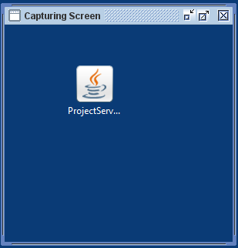
Figure 14 Server Window (Capturing screen)
After the Successful connection user can now perform various tasks using mouse clicks. The user can access drives, view his downloads, view his emails or monitor any other work in progress.
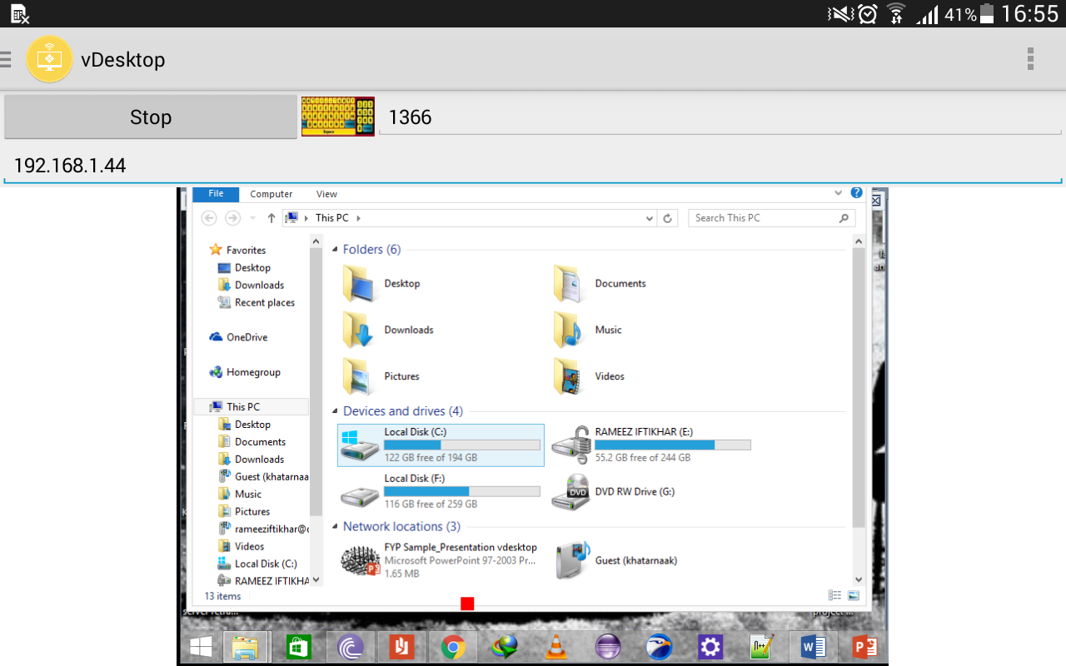
Figure 15: Devices and drives

User can also see the connection details of his network to check whether he is connected to the same network as his server computer.
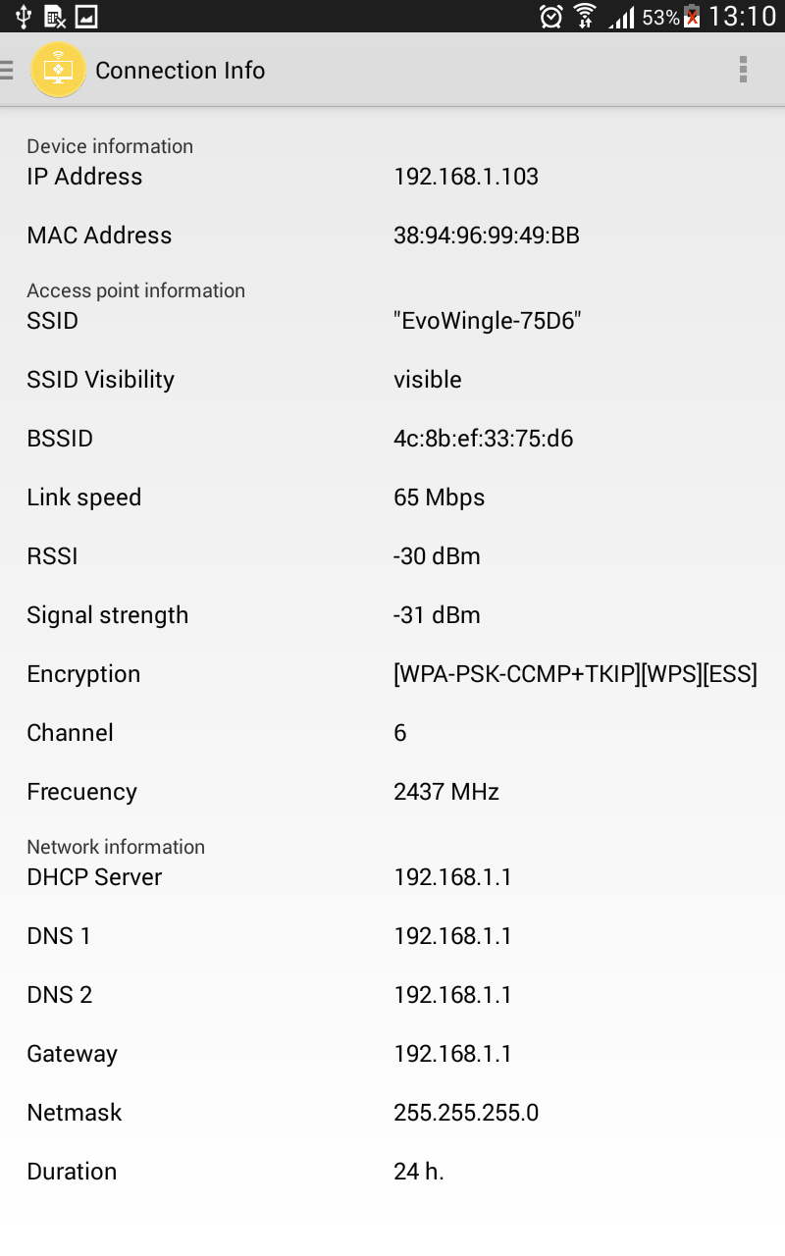

Figure 15: Connection Details
User can also read instructions on how to use the application and can know about the developers
User can simply close the server program or he can also shut down the computer itself or he can put it to sleep mode.
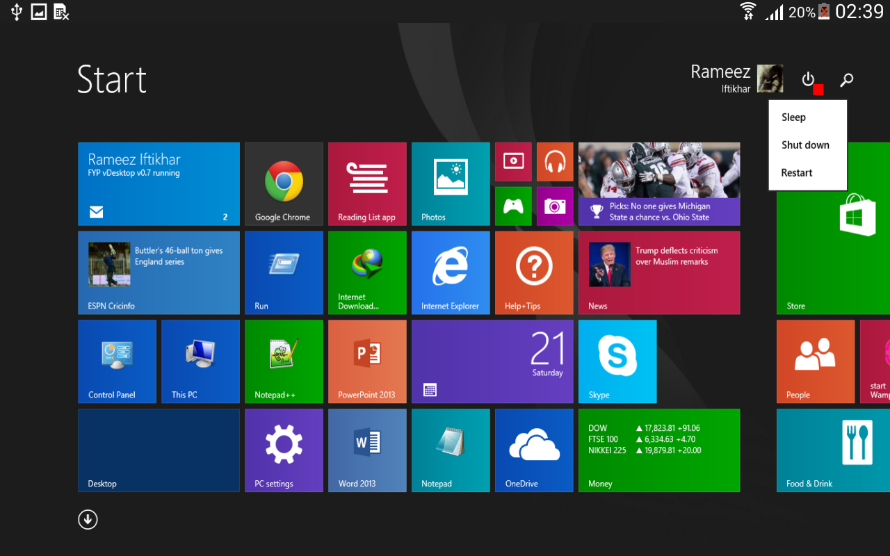
Figure 16: Power options
We have used sliding menu to design our client application which is a very popular design these days in phone applications. The user can slide on the screen to switch menus or go through all the activities.
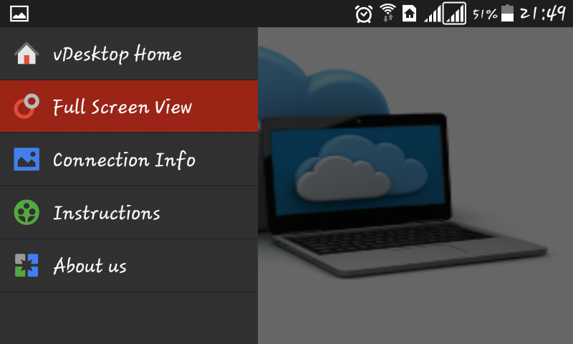
Figure 17: Design to swap activities
The User can also take screenshots of the unique moments and save them directly to their smart phones.

CONCLUSIONS &RECOMMENDATIONS

Results

The main goal of the project was to develop a remote control system for computers in an Android platform using Wi-Fi and Java. The client and server applications of this thesis project would enable Wi-Fi connection between the phone and computer, and once connected the application would give the user full control of the computer’s mouse and keyboard. The mobile application was developed for Android version 4.2. The server application was developed for the computer and is compatible with any computers having JDK 1.7 or above installed. As the applications use Wi-Fi to communicate between the client and server devices, both devices should be connected to the same network.
The client application was developed using Samsung Galaxy III phone. However different brands of Android phones have different features that might cause the application to behave differently. The client and server applications have been tested using different Android phones and laptops simultaneously. The applications worked well in all the devices when they were connected to same network. This project can only be used for the computers that use English language layout keyboard. The application sometimes can crash as Internet connection might not work properly.
Thus, despite of several limitations, a functional remote desktop application was developed. However further modification can be done to the server and client applications to fix the errors and to provide additional features.

Discussion

A few years ago developing application was meant only for PCs. Hardware and software requirements for PC applications to be able to run are very high. Furthermore applications development requires dedication and involvement of a large number of skilled people. However with the launch of the smartphone the concept has changed. Now applications are also meant for mobile phones. To make mobile applications dedication and involvement of a large number of skilled people is not necessarily required. Such applications can be made by a single person and an application developer can get involved in such development as a profession or as a hobby.
Android has a good and well conducted market for developers to sell their applications. These types of platform have given people chances to expose their skills. Moreover Android being an open source people gets more interested in application development. Open source means that the source code of the applications are available to public for use and modification from its original design. Android has got plenty of guides on setting up the environment for application development, getting stated with the application development and putting developed applications in the market for selling. So applications can be developed easily if developers’ guides are followed properly. Also several sensors are available on the Android phones. As this project used Bluetooth, it was found out that Bluetooth can be used for different purposes other than using it as a communicator for a remote control for computers.
This project was developed for an Android device using the software version 4.2. So in the future this project can be further used or modified to run the application on any Android phones. The project was completed within the projected time. Though the project is ready for use, it still contains some bugs. The main drawback of the project is that it cannot be used for other layout keyboards except the one in English. This is because Java does not provide key events for the keys for keyboard layouts in language other than English. If the application has to be made for such keyboards, then the key events must be created in Java manually through coding. These bugs can be fixed during the process of debugging. Since the project uses Wi-Fi, the battery of the Android phones can drain out quickly.
Developing the server application was easy compared to the client application as Java has more online as well as printed materials for reference than Android. In the case of the client application, the developers’ guide provided by Android was not enough to learn some specific task, so helps had to be taken through third party sites. Android does not have enough and good quality printed books for reference. Developing applications can be a time consuming process. Therefore weekly planning and time management was required to complete the project within the expected time.
Android phones are very popular but still have some drawbacks. The battery drains out rapidly on using the Internet or while using an application that uses the resources of a mobile. So whenever a developer develops an application he or she has to be careful about the battery power drainage. Also in long use of such applications the battery gets slightly heated.
More and more new Android phones are being introduced. Every phone does not have the same configurations. So a developed application may not work for all devices. This slightly decreases the possibility of people taking application development as a profession. For those people who work as part time developers or who work alone, selling applications in the Android market does not cover their living expenses. Also regarding the security of the Android market, there have been a few cases where malicious software was hidden in an application and launched to the market.
The project can be a good reference for developing any Wi-Fi related applications. Additional features can be added to the applications. This project can be made available for multi-lingual keyboard layouts. The untimely crashing of the application and irregularity in the movement of the mouse can be fixed during future development. Additional features such as copying text between the server and client zoom in/out of the display, onscreen keyboard for missing characters and a multi touch for handling the mouse can be added in the project. During modification issues related to security can also be considered.
During this project useful knowledge and experiences were gained. There was success as well as failure. Despite the defects discussed above, this project was successfully completed. Finally the project was shown to many people, requesting for suggestions necessary to make project better. In the future considering the suggestion the project can further be modified and can be made available for downloads through the Android market.

Conclusion
The goal of the project was to develop a remote desktop application using Java with Wi-Fi as a communicating medium. The project gives a user full access to the mouse and the keyboard of the server computer to be handled by using Android phones. This project was mainly targeted to acquire ideas on Android and computer applications development using Java. The project was successfully carried out and was completed within the schedule. Despite being available for use, the application has some bugs in it, such as untimely crashing and irregularity in mouse movement and works only for a keyboard with an English layout.
Simple remote control client and server applications were made using simple Java codes for Android and the computer.

REFERENCES

http:// http://developer.android.com/
http://www.tutorialspoint.com/android/
https://github.com
http://stackoverflow.com/
http://www.androidhive.info/

Abbreviations

APP: Application
EVO:
JDK: Stands for Java Development Kit
GUI: Graphical User Interface
SDK: Stands for Software Development Kit
API: Application Programing Interphase
RAM: Random Access Memory
ADT: Android Development tool
TCP: Transmission Control Protocol
RFB: Remote Frame Buffer
XML: Extensible Markup Language
WIFI: Wireless fidelity

